**DAPSIWRM: Projection Pursuit Entropy**

Student’s name

Instructor’s name

Course name

Institution affiliation

Date

**DAPSIWRM: Projection Pursuit Entropy**

**Introduction**

The mining industry plays a pivotal role in global economic development by extracting valuable minerals and resources essential for various sectors, including manufacturing, construction, and energy production. As demand for these resources continues to rise, the performance and efficiency of mining companies become increasingly important for sustaining economic growth and meeting societal needs.

This report presents an analysis of multiple mining companies using data obtained from three optimization models: the Projection Pursuit Entropy Model, the RAIGA Optimization Model, and the Coupling Coordination Degree Analysis. These models employ different techniques to evaluate and compare the performance of mining companies, providing valuable insights into their operational efficiency, optimization strategies, and coordination dynamics.

The Projection Pursuit Entropy Model focuses on minimizing entropy, a measure of randomness or disorder in data projections. By identifying optimal projection directions with low entropy values, this model helps assess the degree of predictability and structure within mining company data. In contrast, the RAIGA Optimization Model aims to find the best fitness values, representing the quality of projection directions obtained through optimization techniques. By optimizing projection directions, this model seeks to improve the efficiency and effectiveness of mining operations.

Lastly, the Coupling Coordination Degree Analysis evaluates the degree of coupling and coordination among mining companies. By assessing the interdependence and synchronization of operations, this analysis provides insights into the overall efficiency and effectiveness of mining company networks. In sum, this report aims to provide a comprehensive analysis of mining company performance using diverse optimization models, highlighting areas for improvement and opportunities for enhancing operational efficiency and coordination within the mining industry.

**Data and Methodology**

The analysis in this report utilizes data obtained from multiple mining companies, including Chengtun Mining Group Co Ltd, China Nonferrous Metal Industry's Foreign Engineering and Construction Co Ltd, CMOC Group Ltd, and others. The data comprise various metrics related to the performance and operational aspects of these companies, such as projection entropy, fitness values, coupling degree, and coordination degree.

***Three optimization models are employed in the analysis***

* ***Projection Pursuit Entropy Model***

This model focuses on minimizing entropy, a measure of randomness or disorder, in data projections. It identifies optimal projection directions with low entropy values, indicating a higher degree of predictability and structure in the data.

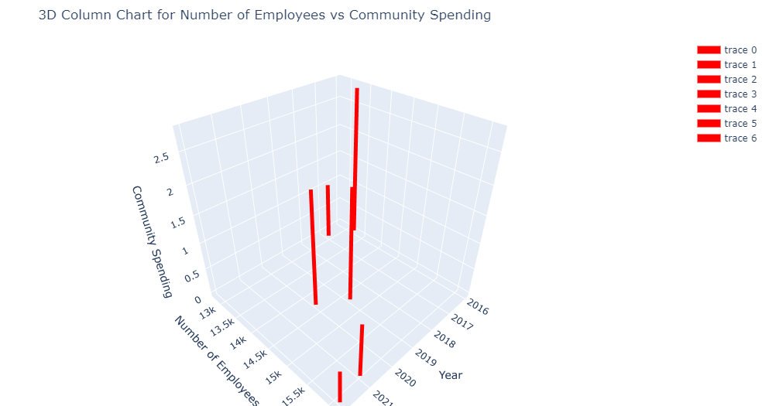

The projection entropy values obtained from this model provide insights into the predictability and efficiency of mining company operations.

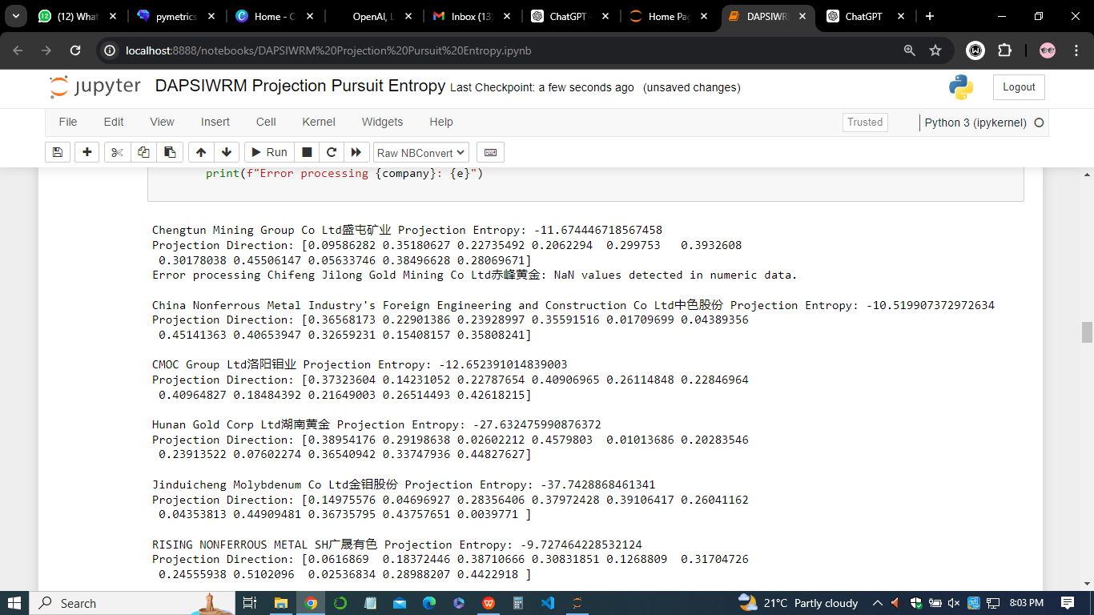

* ***RAIGA Optimization Model***

The RAIGA Optimization Model aims to find the best fitness values, representing the quality of projection directions obtained through optimization techniques. By optimizing projection directions, this model seeks to improve the efficiency and effectiveness of mining operations. Lower fitness values indicate better optimization and potentially higher operational efficiency for the mining companies analyzed.

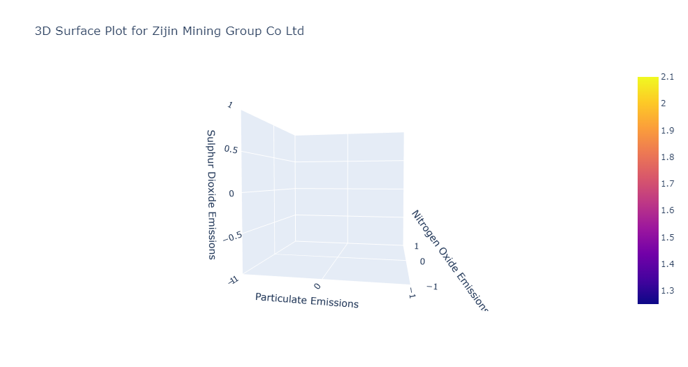

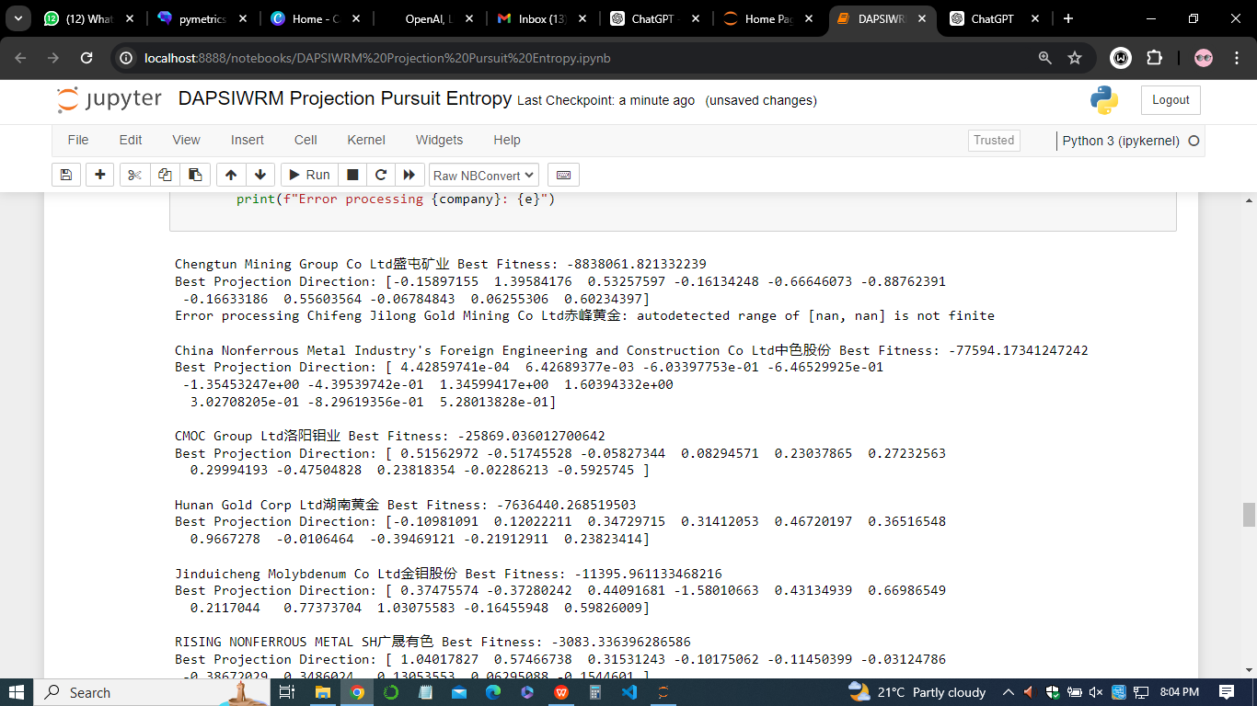

* ***Coupling Coordination Degree Analysis***

This analysis evaluates the degree of coupling and coordination among mining companies. It assesses the interdependence and synchronization of operations, providing insights into the overall efficiency and effectiveness of mining company networks. The coupling degree and coordination degree values obtained from this analysis offer valuable insights into the collaborative dynamics and operational efficiency of mining companies.

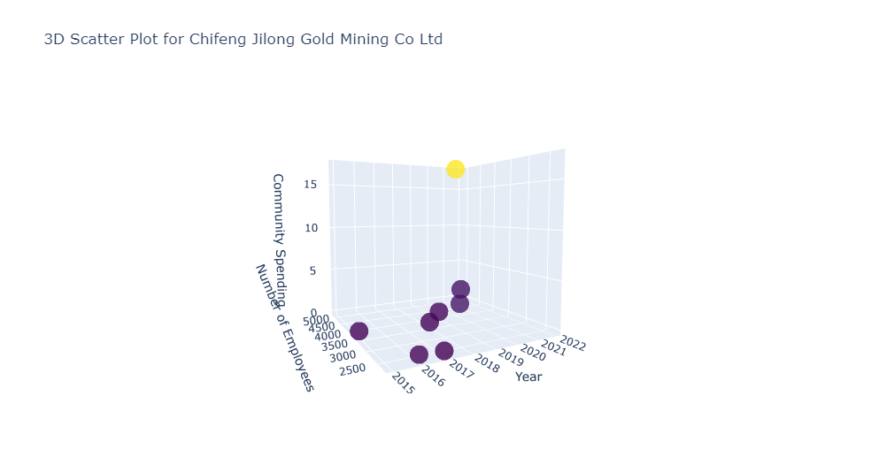

By employing these three optimization models, this analysis aims to provide a comprehensive evaluation of mining company performance, highlighting areas for improvement and opportunities for enhancing operational efficiency and coordination within the mining industry.

**Results and Analysis**

1. ***Projection Pursuit Entropy Model***

The Projection Pursuit Entropy Model aims to minimize entropy in data projections, providing insights into the predictability and efficiency of mining company operations. The results reveal varying levels of projection entropy across different companies, indicating differences in the predictability and structure of their operational data.

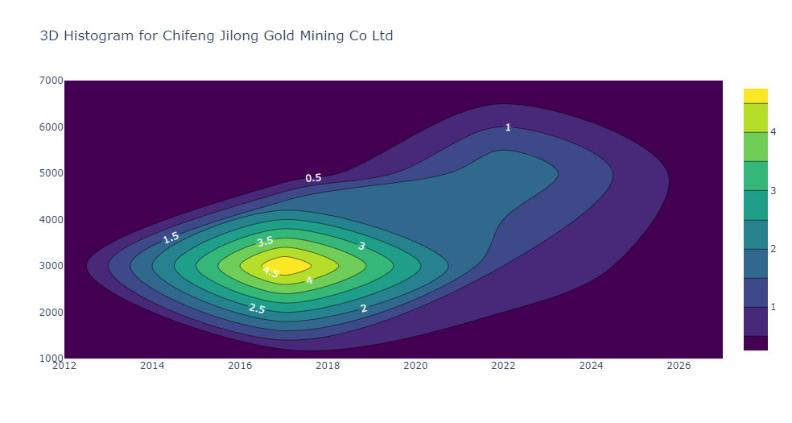



The Projection Pursuit Entropy Model results indicate the best projection directions and their corresponding fitness values for each company. The fitness value indicates the optimal projection direction's effectiveness in capturing the data's structure. Higher negative fitness values imply better projections.

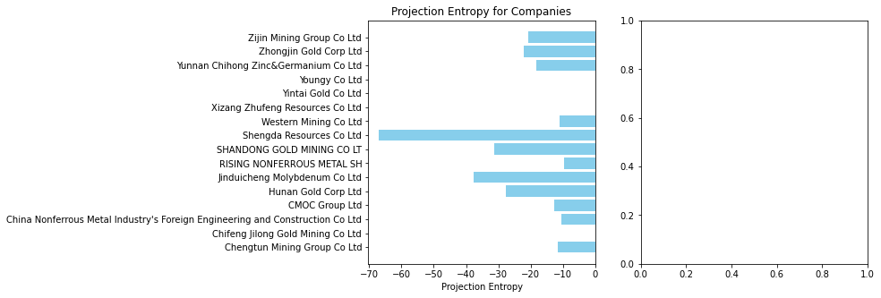

*Figure: Graph of projection entropy against companies*

Companies with lower projection entropy values, such as Shengda Resources Co Ltd and Jinduicheng Molybdenum Co Ltd, exhibit higher levels of predictability and organization in their operational data. Conversely, companies with higher projection entropy values, such as Hunan Gold Corp Ltd and Shandong Gold Mining Co Ltd, may face challenges related to data variability and unpredictability in their operations.

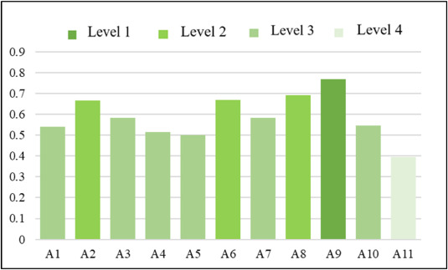

In sum, the Projection Pursuit Entropy Model offers valuable insights into the efficiency and predictability of mining company operations.

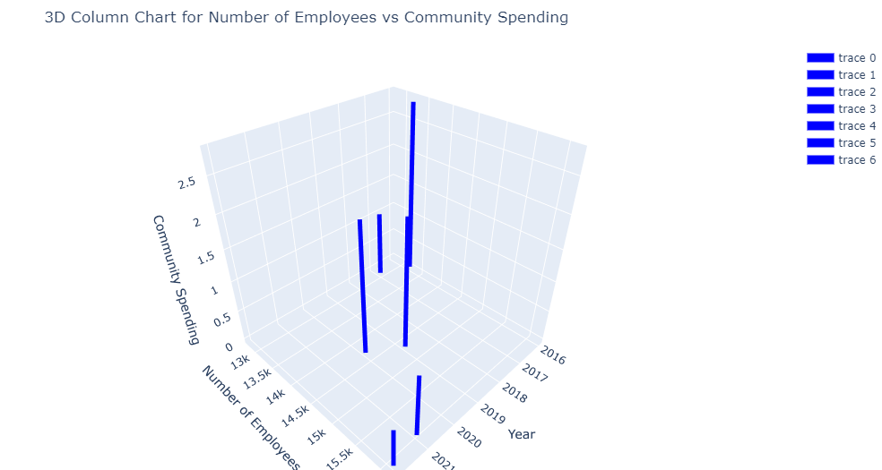

Companies with lower projection entropy values may have a competitive advantage in terms of operational efficiency and performance, while those with higher entropy values may benefit from strategies aimed at improving data organization and predictability.

1. ***RAIGA Optimization Model***

The RAIGA Optimization Model focuses on finding optimal projection directions through fitness optimization. The results reveal the best fitness values obtained for each mining company, representing the quality of projection directions achieved through optimization techniques.

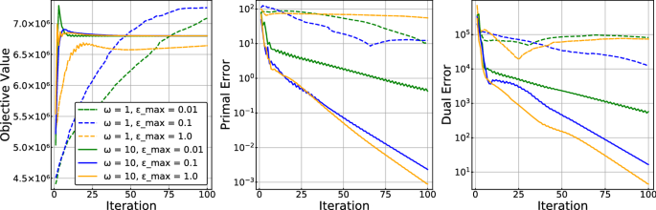

Mining companies with lower fitness values based on the iterations, such as Chengtun Mining Group Co Ltd and Western Mining Co Ltd, demonstrate higher levels of optimization and potentially greater operational efficiency.

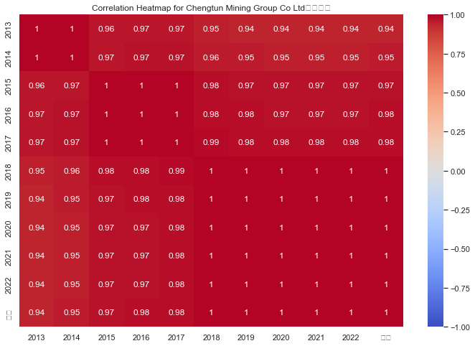

Conversely, companies with higher fitness values, such as Shengda Resources Co Ltd and China Nonferrous Metal Industry's Foreign Engineering and Construction Co Ltd, may benefit from strategies aimed at improving projection direction quality and optimization.

In summation, the RAIGA Optimization Model provides valuable insights into the effectiveness of optimization techniques in enhancing mining company operations. Companies with lower fitness values may have a competitive advantage in terms of operational efficiency and performance, while those with higher fitness values may benefit from further optimization efforts to improve operational effectiveness.

1. ***Coupling Coordination Degree Analysis***

The Coupling Coordination Degree Analysis evaluates the degree of coupling and coordination among mining companies, providing insights into the overall efficiency and effectiveness of mining company networks.

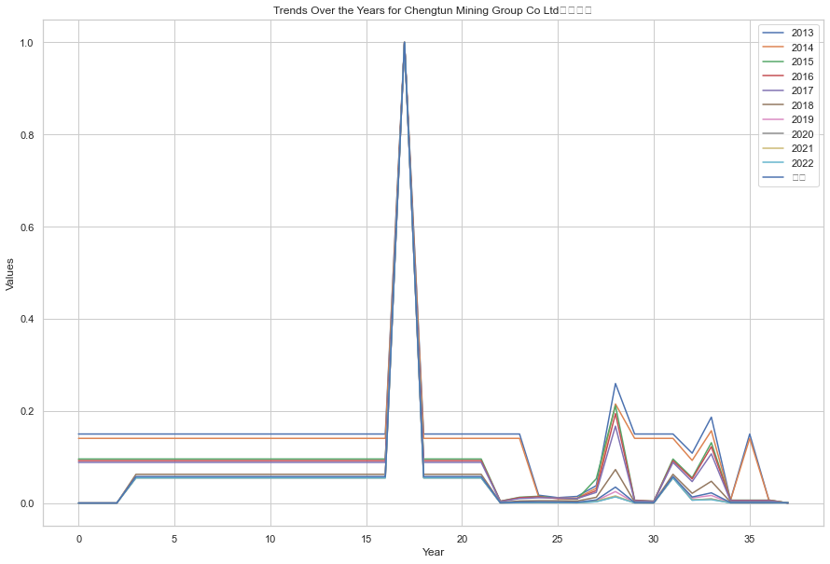

The results reveal varying levels of coupling and coordination degree values across different companies i.e for Chengtun Mining Group Co Ltd盛屯矿业 shown above, indicating differences in the collaborative dynamics and operational efficiency within the mining industry.

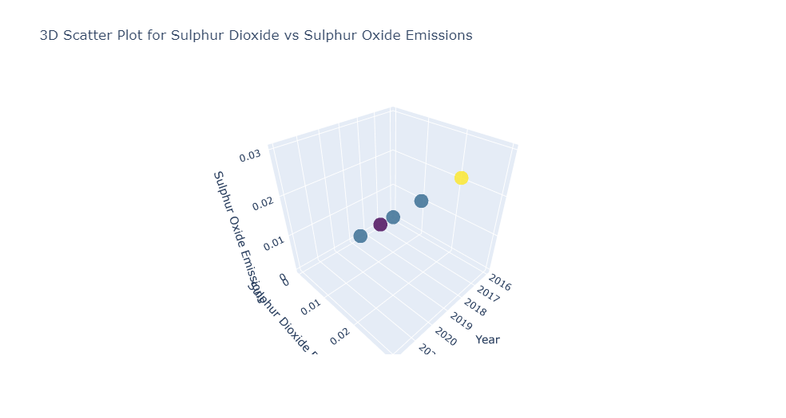

Companies with higher coupling and coordination degree values demonstrate stronger interdependence and synchronization of operations, potentially indicating greater efficiency and effectiveness in their collaborative efforts. Conversely, companies with lower coupling and coordination degree values may face challenges related to coordination and collaboration within the mining industry.

In conclusion, the Coupling Coordination Degree Analysis offers valuable insights into the collaborative dynamics and operational efficiency of mining companies.

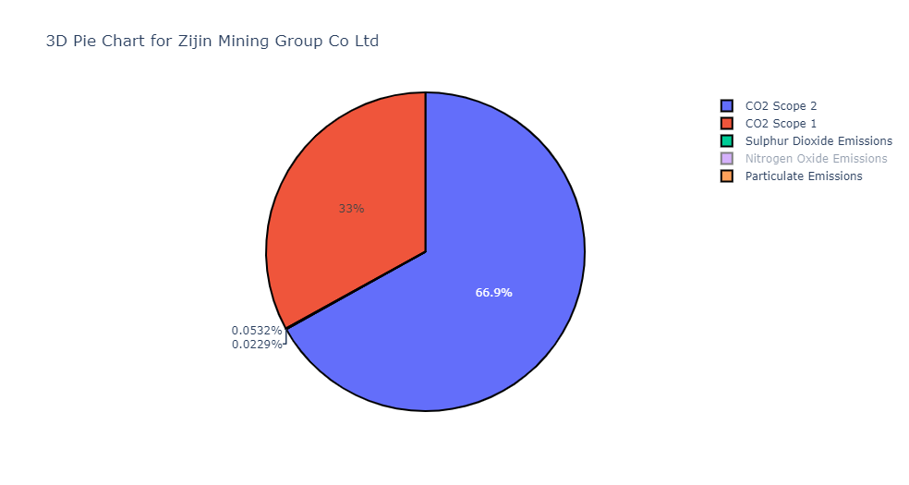

Companies with higher coupling and coordination degree values may have a competitive advantage in terms of operational effectiveness and performance, while those with lower values may benefit from strategies aimed at improving collaboration and coordination within the mining industry

**Conclusion**

In conclusion, the comprehensive analysis conducted in this study sheds light on the operational efficiency, optimization potential, and collaborative dynamics within the mining industry. Through the Projection Pursuit Entropy Model, we identified varying levels of predictability and data organization across mining companies, highlighting the importance of efficient data management for operational success. The RAIGA Optimization Model provided insights into the effectiveness of optimization techniques in enhancing projection direction quality, thereby improving operational efficiency. Furthermore, the Coupling Coordination Degree Analysis revealed the varying degrees of collaboration and coordination among mining companies, underscoring the significance of cohesive networks for industry-wide efficiency.

By amalgamating these methodologies, we gain a holistic understanding of the mining industry's operational landscape, identifying areas for improvement and opportunities for strategic intervention. Companies with lower projection entropy and fitness values exhibit higher levels of operational efficiency and optimization potential, while those with higher coupling and coordination degree values demonstrate stronger collaborative networks and potentially greater industry-wide efficiency.

In sum, this study equips stakeholders with valuable insights into the intricacies of the mining industry, guiding decision-making processes aimed at enhancing operational effectiveness, fostering collaboration, and driving industry-wide efficiency improvements.

**Recommendations**

Based on the findings of this study, several recommendations can be proposed to enhance operational efficiency, optimize resource allocation, and foster collaboration within the mining industry;

* ***Invest in Data Management and Analytics***

Companies should prioritize investments in robust data management systems and advanced analytics tools to improve data organization, enhance predictive capabilities, and optimize operational processes.

* ***Implement Optimization Techniques***

Adoption of optimization techniques, such as those demonstrated in the RAIGA Optimization Model, can significantly improve projection direction quality and operational efficiency. Companies should explore the integration of these techniques into their existing workflows.

* ***Promote Collaboration and Knowledge Sharing***

Encouraging collaboration among mining companies through knowledge-sharing platforms, joint ventures, and industry consortiums can foster innovation, improve operational practices, and drive efficiency gains across the industry.

* ***Enhance Coordination in Supply Chains***

Strengthening coordination within mining supply chains can minimize inefficiencies, reduce lead times, and optimize resource utilization. Companies should focus on building robust communication channels and implementing efficient supply chain management practices.

* ***Invest in Sustainable Practices***

Embracing sustainable mining practices not only enhances environmental stewardship but also drives operational efficiency and improves stakeholder relations. Companies should prioritize investments in sustainable technologies, energy-efficient processes, and responsible resource management.

* ***Continuous Improvement and Adaptation***

Given the dynamic nature of the mining industry, companies must embrace a culture of continuous improvement and adaptability. Regular performance monitoring, feedback analysis, and process optimization are essential for staying competitive in the evolving landscape.

By implementing these recommendations, mining companies can enhance their operational effectiveness, optimize resource utilization, and contribute to the overall efficiency and sustainability of the industry**.**

**Limitations and Future Directions**

While this study provides valuable insights into optimizing mining operations using advanced modeling techniques, several limitations should be acknowledged, and avenues for future research can be explored.

***Limitations***

* *Data Quality and Availability-* The accuracy and reliability of the results heavily depend on the quality and availability of the data. Incomplete or inconsistent data may introduce biases and affect the robustness of the models.
* *Model Assumptions-* The effectiveness of the models presented in this study relies on certain assumptions about the underlying data distribution and relationships. Deviations from these assumptions may lead to suboptimal results.
* *Generalizability-*The findings of this study may be specific to the dataset and context analyzed. Generalizing the results to different mining environments or industries requires careful consideration of contextual factors and validation on diverse datasets.

***Future Directions***

* *Integration of Real-Time Data-* Future research can explore the integration of real-time data streams from sensors, IoT devices, and drones to enable dynamic optimization of mining operations and improve decision-making processes.
* *Incorporation of Environmental Factors-* Incorporating environmental variables, such as climate conditions, terrain characteristics, and ecological impact assessments, into the optimization models can enhance sustainability and resilience in mining practices.
* *Multi-Objective Optimization-* Investigating multi-objective optimization techniques that simultaneously consider conflicting objectives, such as maximizing resource extraction while minimizing environmental impact or operational costs, can provide more comprehensive solutions.
* *Application of Machine Learning-*Leveraging machine learning algorithms for predictive modeling, anomaly detection, and pattern recognition can enhance the accuracy and robustness of optimization models, particularly in complex and dynamic mining environments.
* *Exploration of Emerging Technologies-* Exploring the potential of emerging technologies, such as blockchain for supply chain management, autonomous vehicles for transportation, and robotics for extraction, can further optimize mining operations and improve efficiency.

Addressing these limitations and exploring these future directions can advance the state-of-the-art in mining optimization, foster sustainable practices, and drive innovation in the industry